* 1. Ordered quantities are still not showing up in the order list/history tab

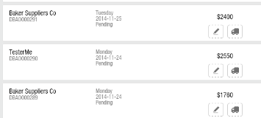

Should also show total pieces ordered.

* 1. Using order 00291 as reference. Why does it say shorts as 100?

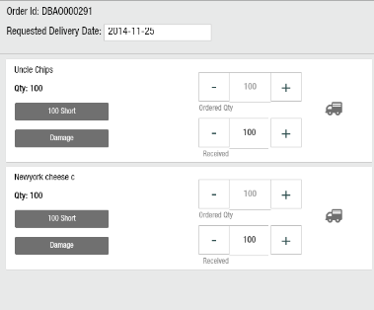

I reduced the received for uncle chips to 90. Shorts should now be only 10. But its not updated correctly. Still shows up as 100.

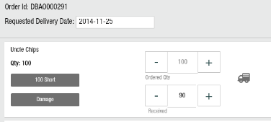

* 1. Next I received 90 quantities of uncle chips by pushing the small truck icon in front of the line item. Why does it update the confirmed quantity to 0? Confirmed should continue being 100, received would be 90 and shorts would be 10.

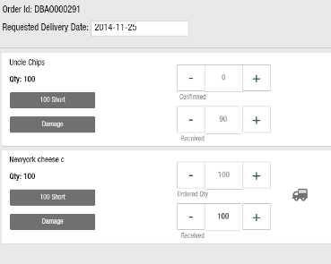

* 1. Next, I am now going to receive all other products with the header truck .

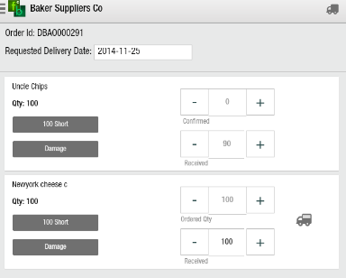

No confirmation / pop up received. How do I get to know if I have received the order?

Next I go back to order history to check the status of this order. Says received 90 and short 10. That;s not correct. Out here total pieces have to be reported (by aggregating all items in the product).

